Finding Youngest Student in Class

(Developed by Chitra P, Thiagarajar College of Engineering, Madurai, India)

Course Level:

CS0/CS1/CS2

PDC Concepts Covered:

PDC Concept | Bloom Level
Serial vs Parallel (Speed UP) | K
Partitioning | K
Parallel Overhead | K
Sequential Dependency | K
Load Imbalance | K

Prerequisites:
None

Tools Required:
Students in a classroom seated row wise in multiple columns
Introduction:
The main goal of this module is to introduce the basic steps of parallelization namely partitioning, mapping, and synchronization.
Partitioning or decomposition is the division of the problem into smaller subproblems.
Mapping is the task of assigning what data to which thread.
Synchronization is how the threads communicate to ensure the parts of the task are done in the right order.

Activity Description:
- The students in the classroom are asked to sit in an arrangement somewhat similar to figure 1.
- The students are asked to find the youngest student in the room.
- Each group of students in the same row find out the youngest student in their row by exchanging information.
  - The answers are available as Y1, Y2, ... Y6.
- Once each group has an answer, they pass that information to a person in group 1. This student compares the compares the results and announces the age of the youngest.
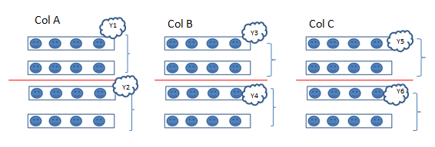
Figure 1: Students arranged in rows and columns. Y1, Y2, ... Y6 are the youngest values in each group

Important Notes:
- The partitioning step in this case is the realization that the youngest of a group formed from the youngest from many groups is the same as the youngest of everyone.
- The mapping step is the creation of the groups of students.
- The synchronization step is how the different groups communicate the youngest to the first group so that the global youngest can be found.
- Several additional parallel concepts can be illustrated using the activities. It is up to instructor how many concepts and in how depth they want to cover them
  - Communication between the process can be illustrated by making the students write the results on the board (shared memory) or orally communicating to the particular student (message passing).
  - Load Imbalance can occur if the groups are different sizes.
Extensions:

Let the class come up with their own methods for partitioning themselves to find the youngest. This activity can be expanded to talk about the limits of parallelism. If there were one thousand students could they find the youngest faster than one hundred? Would it make any sense to use an additional level of grouping?

